UECA PD FEST SYDNEY

May 12th, 2018

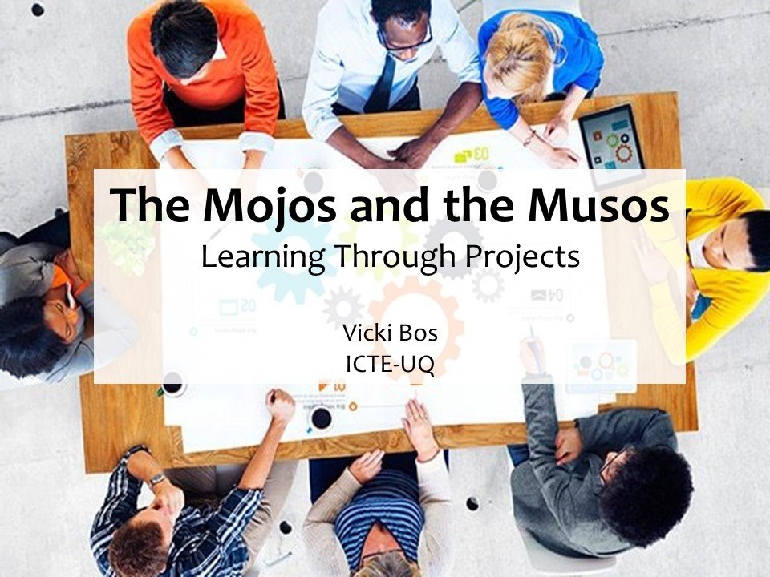

MoJo Example Materials

- Storyboarding

Let’s test your simple storyboarding skills! Draw a three-panel comic telling a story about your morning.

- Film-making Terminology

Watch the short MoJo about The King of Coffee and tick () the things you see and hear.

Visuals | Sounds
- close up | - sound effects
- medium shot | - voiceover
- wide shot | - repetition of words
- close-up with wide shot in the background | - music
- reflection shot | - background noise
- still shot | - outside noise
- interview
- people looking directly at the camera
- the film-maker

https://www.youtube.com/watch?v=3s9XprJihr8

- Music in Film-making

Watch the video about how music affects the opening scene of The Lion King, and make notes in the table.
https://www.youtube.com/watch?v=ecYgqLml89c

The Lion King | Type of music | Feelings/Emotions/Thoughts
No music
Example 1
Example 2
Example 3
Example 4
Example 5
Original music

Muso Example Materials

- Clichés and censorship

a) Look at the following pairs of expressions and decide which one is probably used more often. Explain your choices.

- cold as ice
cold as a razor blade
- My joy is broken.
My heart is broken.

b) Complete the following expressions with a partner. Try to say something original.

as warm as …

My heart is …

You have …

c) When we talk about censorship and creativity, censorship usually means being silenced through direct or implied criticism.
What are some of the sources of censorship in our lives? ___________________________

- How songs work

Look at the ideas in the box and decide whether they are referring to the verse or the chorus of a song.

is more abstract tells the story creates a more emotional response
doesn’t contain context doesn’t make a lot of sense by itself
summarises the whole idea of the song
is often in order (e.g. chronological) is an explanation of the main idea
is more easily recognised by listeners sets the context

- Theme Message Key Phrases Mood

Now take the theme of “Love” and look at the example messages and key phrases you could get from it. Add more key phrases for the messages below.

LOVE
Message
You are special to me You are beautiful Together forever
Key phrases
You’re my oxygen Your smile is a diamond grow old together

Mood/Tone
Decide if the song is happy, angry, sad, funny, mournful, light-hearted, epic, etc…

